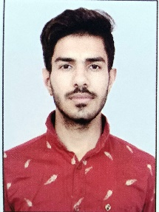**MEHUL VYAS**

+91 6263 555168

Email Id: [vyasm5347@gmail.com](mailto:vyasm5347@gmail.com)

**OBJECTIVE**

Secure a responsible career opportunity to fully utilize my training and skills, while making a significant contribution to the success of the company.

**EDUCATIONAL** **QUALIFICATION**

* Pursuing B.tech 3rd year (v sem) from Shri Vaishnav vidyapeeth Vishwavidyalaya,Indore
* Passed out 12th from CBSE in 2020

Marks 79%

* Passed out 10th from CSBE in 2018

Marks 71.4%

**OTHER** **ACADAMIC** **DETAILS**

**Minor Project :** Online Food ordering Website , Weather forecasting Website

**TECHNICAL** **SKILLS**

**IT Skills:** Data Structure, Algorithms, Object Oriented Programming.

* Programming language – C/C++, Python.
* Web development – HTML , CSS, Java Script, PHP, MySql.

**WORK EXPERIENCE**

FRESHER

**STRENGTH & HOBBIES**

* Hard & Smart Working
* Honest & Punctual
* Good Communication skill
* Arts, Drawing, Cricket, Reading books

**PERSONAL** **DETAILS**

Father’s Name :Mr. Kailash Narayan Vyas

Date of Birth : 20-05-2002

Address : 100, Shri Ram Nagar , Ujjain

Martial Status : Unmarried

Date – 13 Dec 2022 (Mehul vyas)

**Declaration:** I hereby declare that the information furnished above is true to the best of my knowledge.